CLOUD COMPUTING

LAB 12



Submitted To:

Engr. Shoaib

Submitted By:

Komal Kashif

BSE V-A

2023-BSE-031

**Task 1 — Organize Terraform code into separate files**

task1_project_directory.png



task1_files_created.png



task1_variables_tf.png

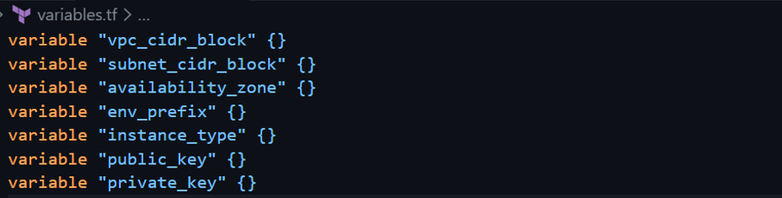

task1_outputs_tf.png

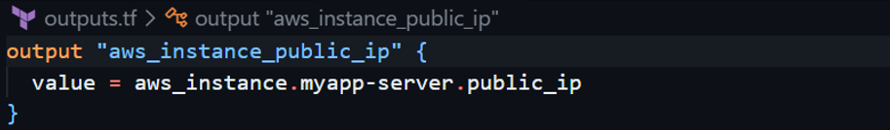

task1_locals_tf.png

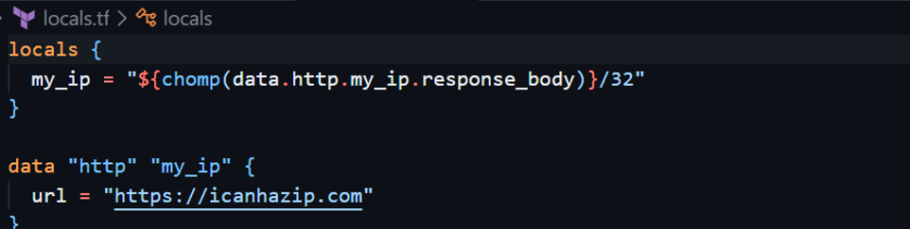

task1_terraform_tfvars.png

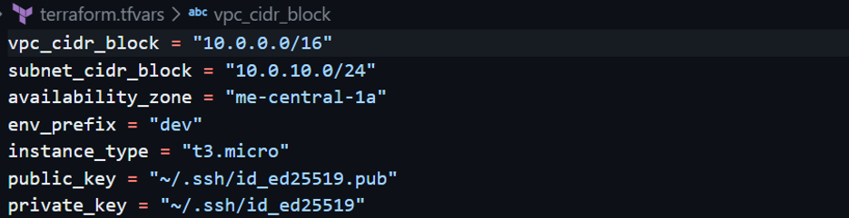

task1_main_tf.png

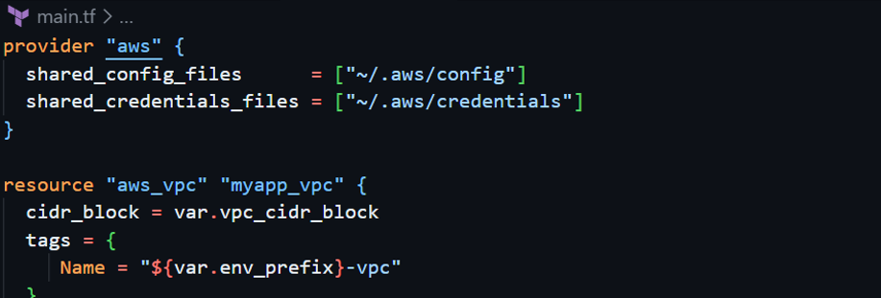

task1_entry_script.png

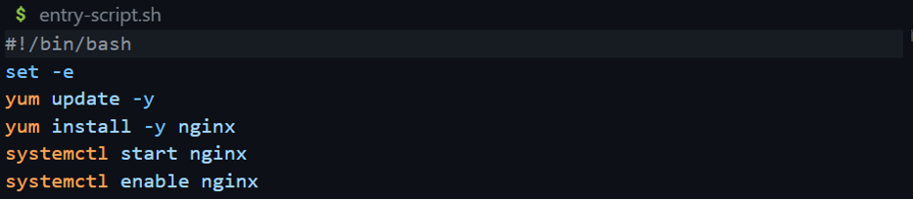

task1_ssh_keygen.png

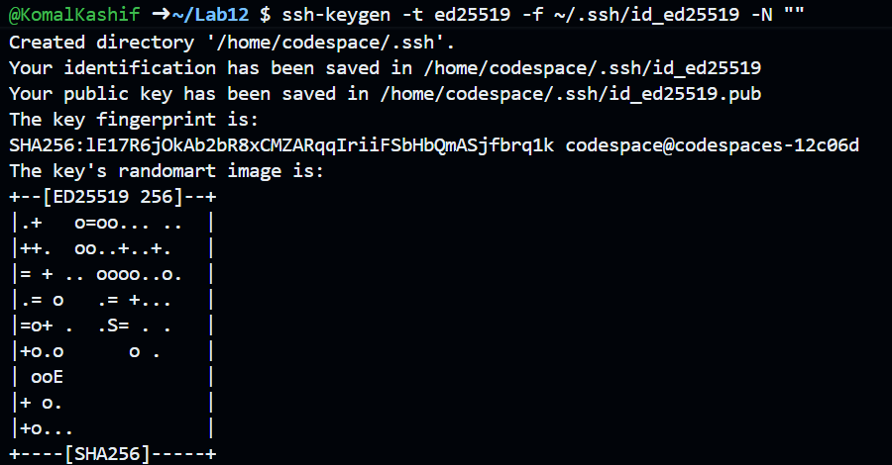

task1_terraform_init.png

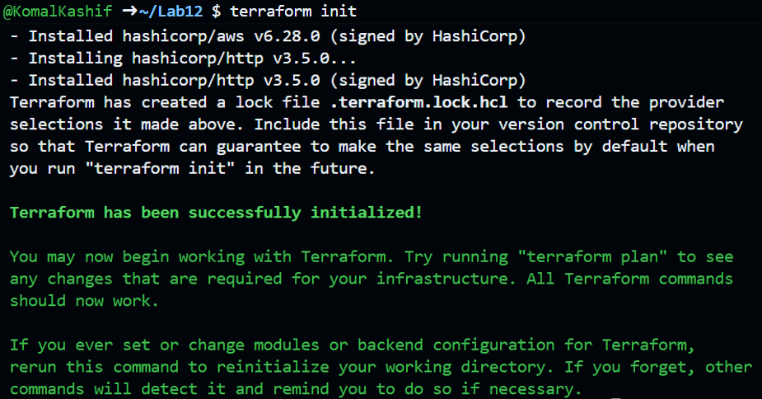

task1_terraform_apply.png

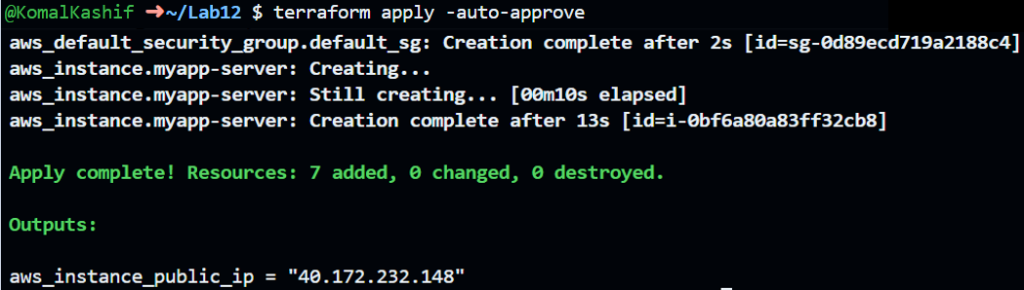

task1_terraform_output.png



task1_nginx_browser.png

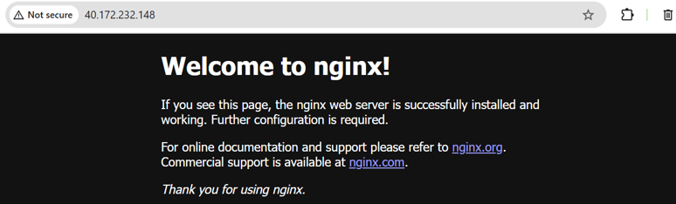

task1_terraform_destroy.png

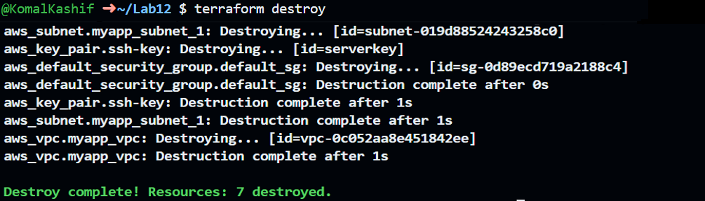

**Task 2 — Use remote-exec provisioner**

terraform apply -auto-approve

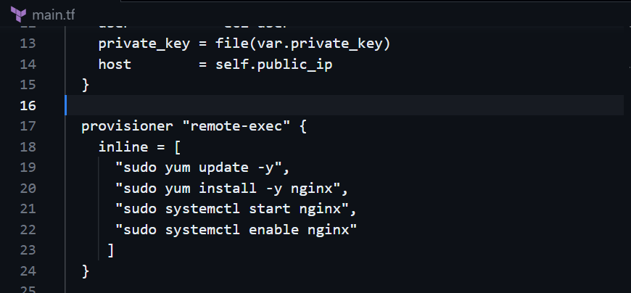

task2_terraform_apply.png

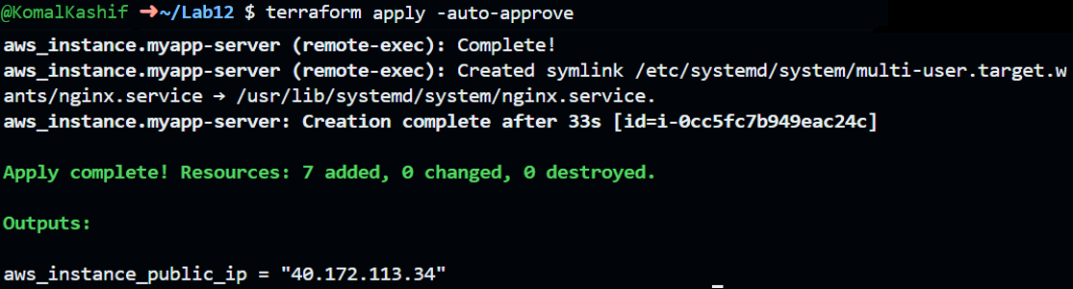

task2_terraform_output.png



task2_nginx_browser.png



**Task 3 — Use file and local-exec provisioners**

task3_main_tf_all_provisioners.png

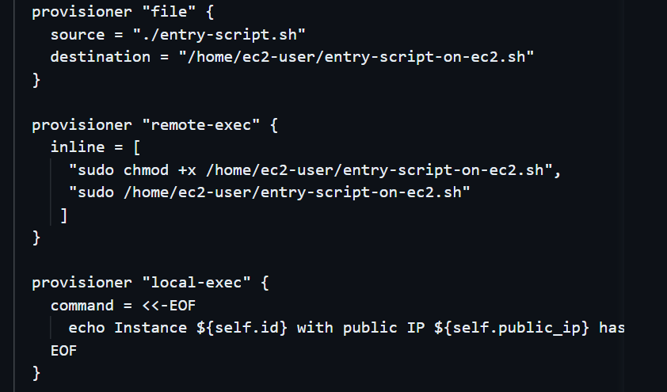

task3_terraform_apply.png

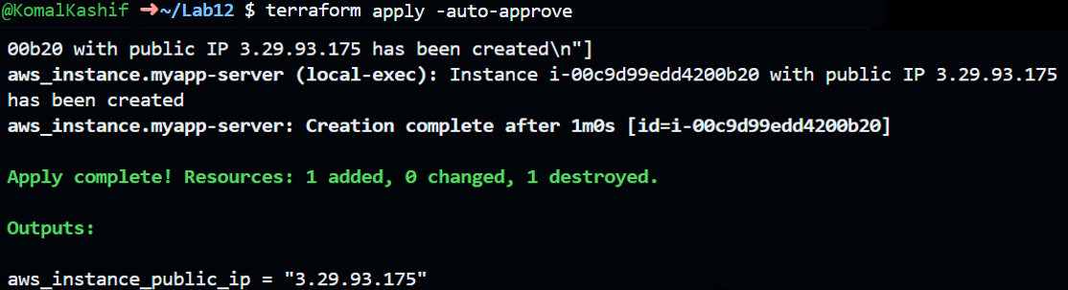

task3_terraform_output.png



task3_nginx_browser.png

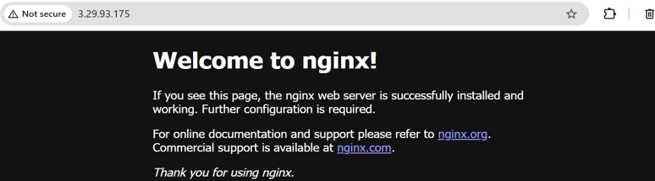

task3_terraform_destroy.png

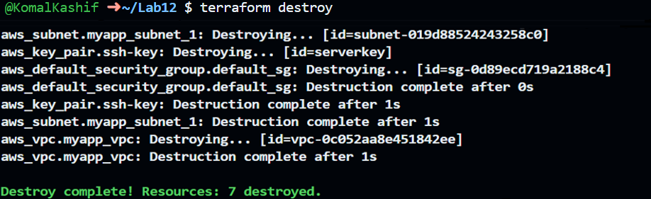

task3_main_tf_restored.png

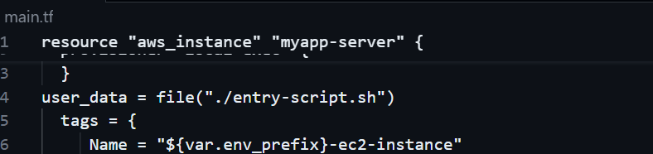

**Task 4 — Create Terraform modules**

task4_module_structure.png

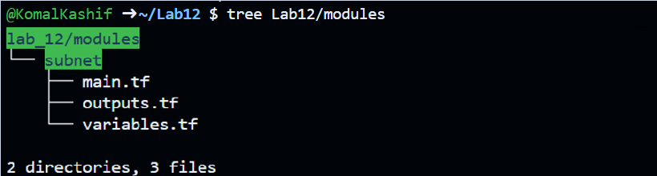

task4_subnet_variables.png

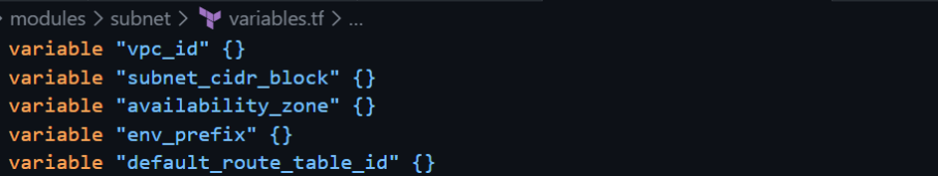

task4_subnet_main.png

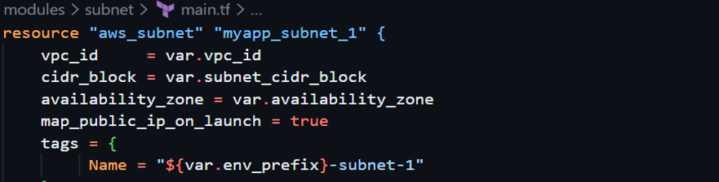

task4_subnet_outputs.png

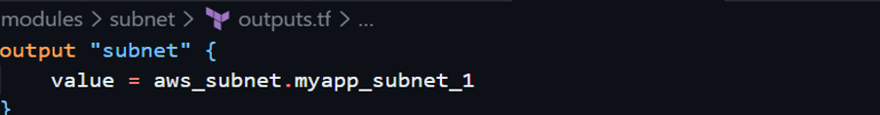

task4_main_tf_with_module.png

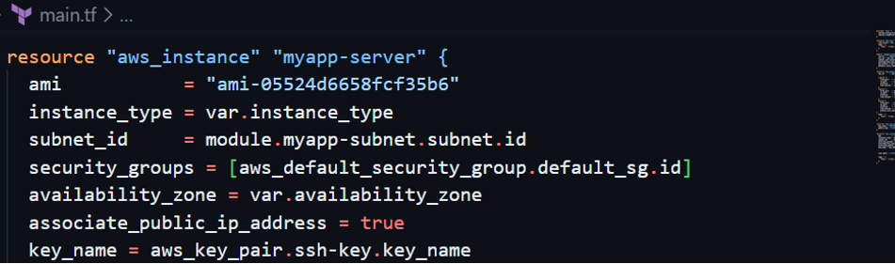

task4_terraform_init.png

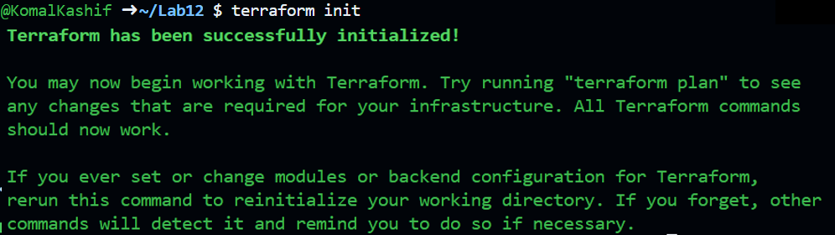

task4_terraform_apply.png

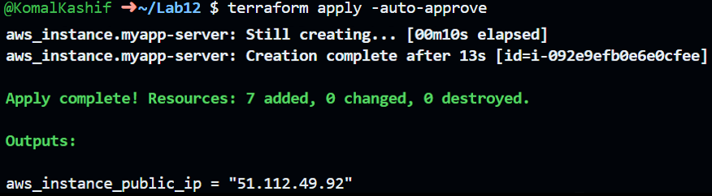

task4_terraform_output.png

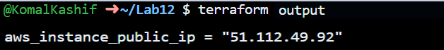

task4_nginx_browser.png



**Task 5 — Create webserver module**

task5_webserver_module_structure.png

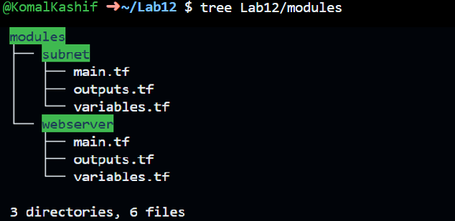

task5_webserver_variables.png

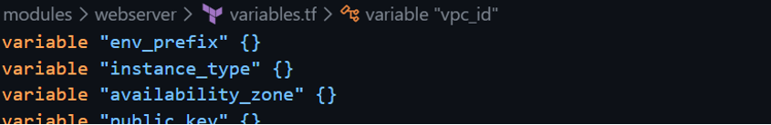

task5_webserver_main.png

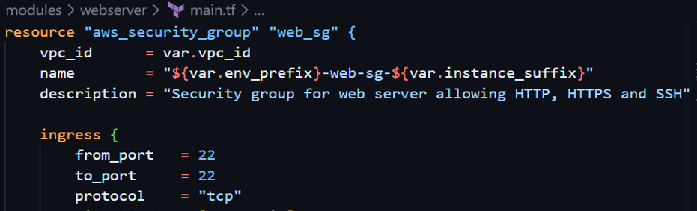

task5_webserver_outputs.png

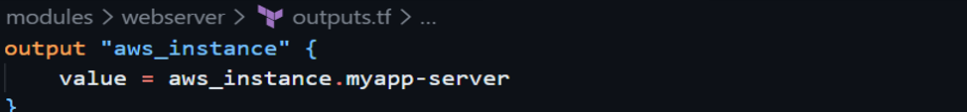

task5_main_tf_webserver_module.png

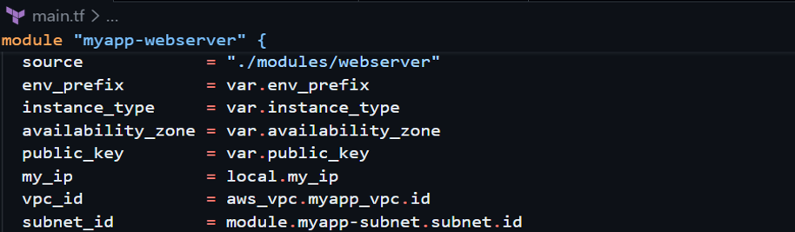

task5_outputs_updated.png

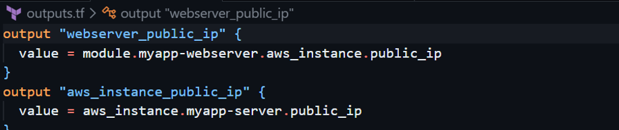

task5_terraform_init.png

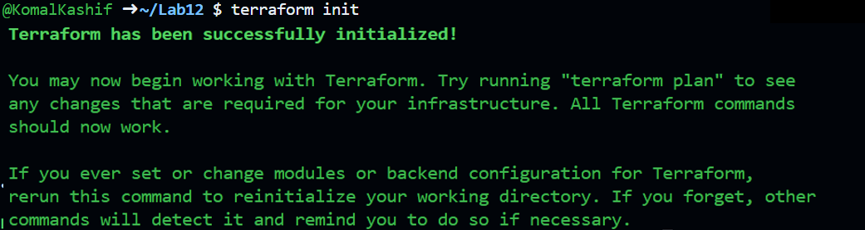

task5_terraform_apply.png

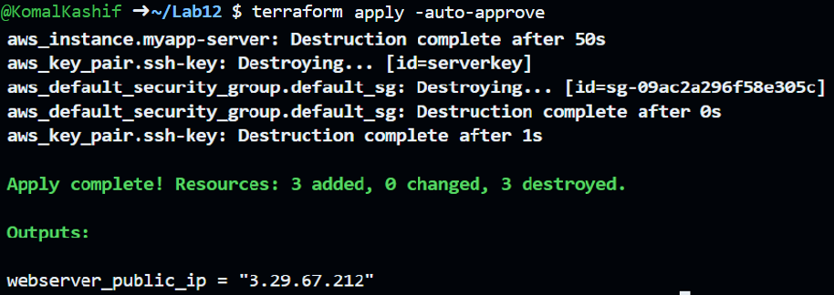

task5_terraform_output.png



task5_nginx_browser.png

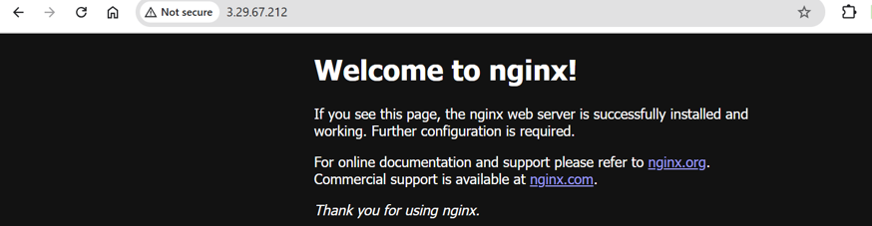

task5_terraform_destroy.png

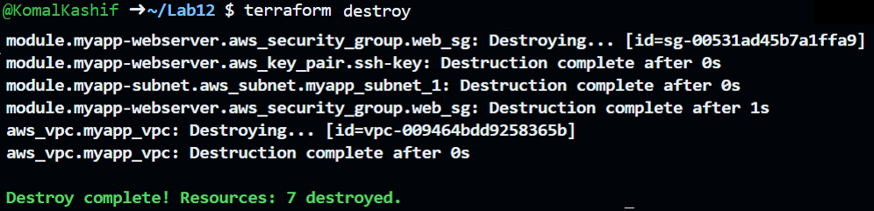

**Task 6 — Configure HTTPS with self-signed certificates**

task6_entry_script_https.png

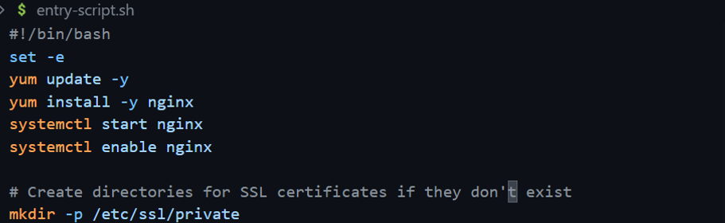

task6_terraform_apply.png

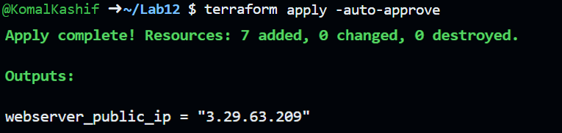

task6_terraform_output.png



task6_http_redirect.png

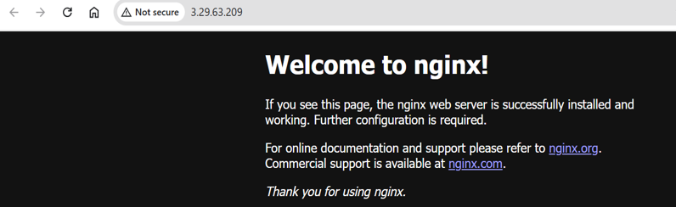

**Task 7 — Configure Nginx as reverse proxy**

task7_apache_script.png

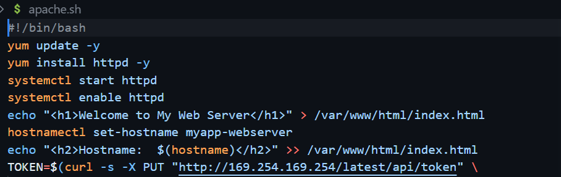

task7_main_tf_web1.png

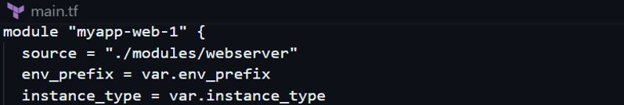

task7_outputs_web1.png

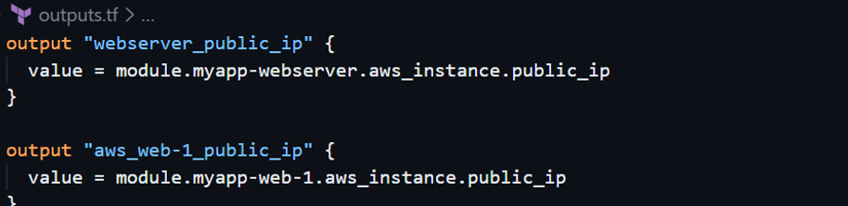

task7_terraform_apply.png

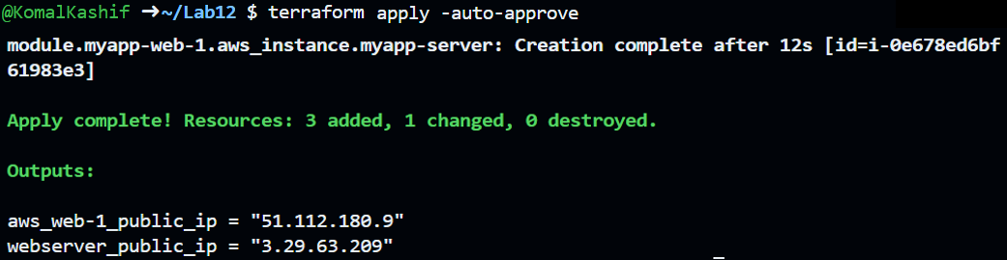

task7_terraform_output.png

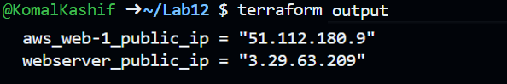

task7_ssh_webserver.png

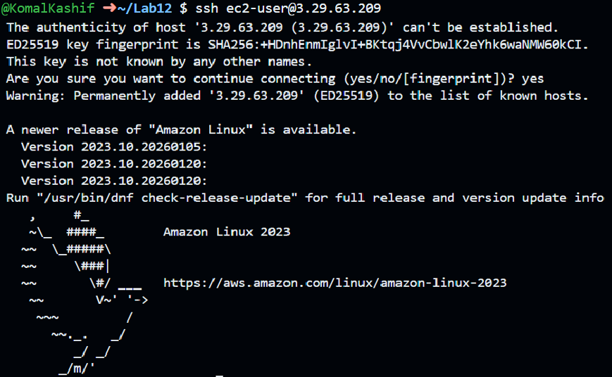

task7_nginx_conf_reverse_proxy.png

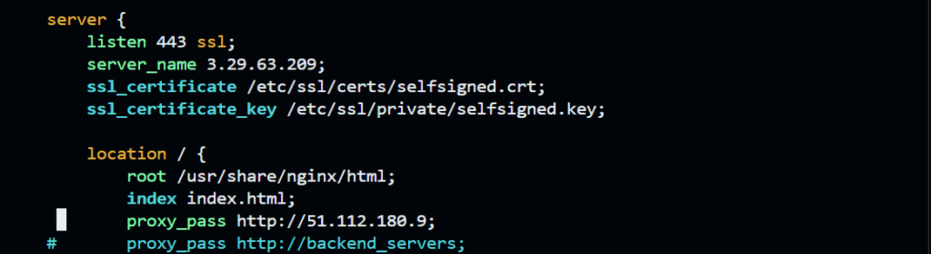

task7_reverse_proxy_browser.png

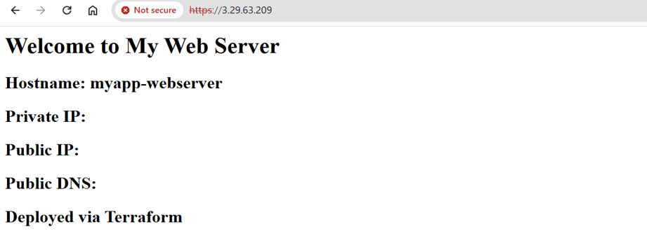

**Task 8 — Configure Nginx as load balancer**

task8_main_tf_web2.png

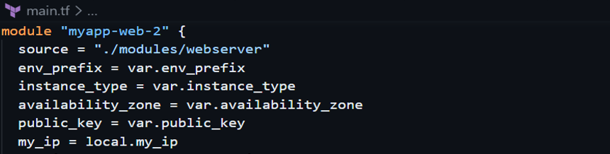

task8_outputs_web2.png

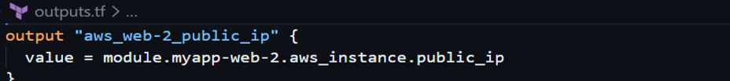

task8_terraform_apply.png

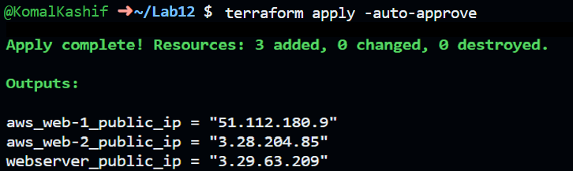

task8_terraform_output.png

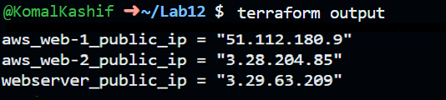

task8_nginx_conf_load_balancer.png

